American Waltham - 12 Size - Metal Open Face - Unusual Digital Disc Seconds Window - Nice Overall Condition - (circa 1930)
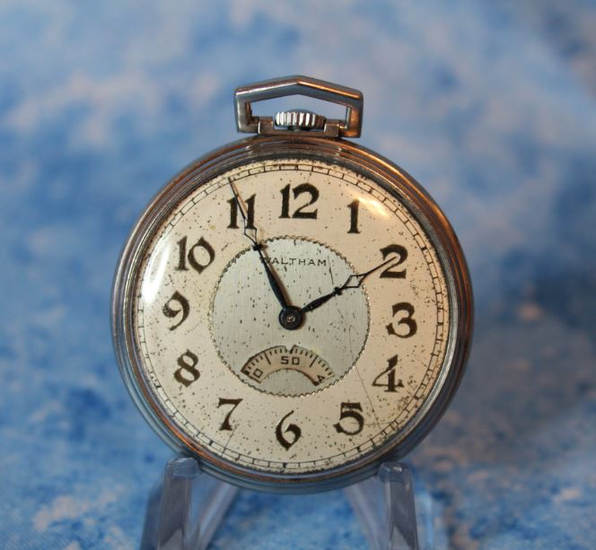 | 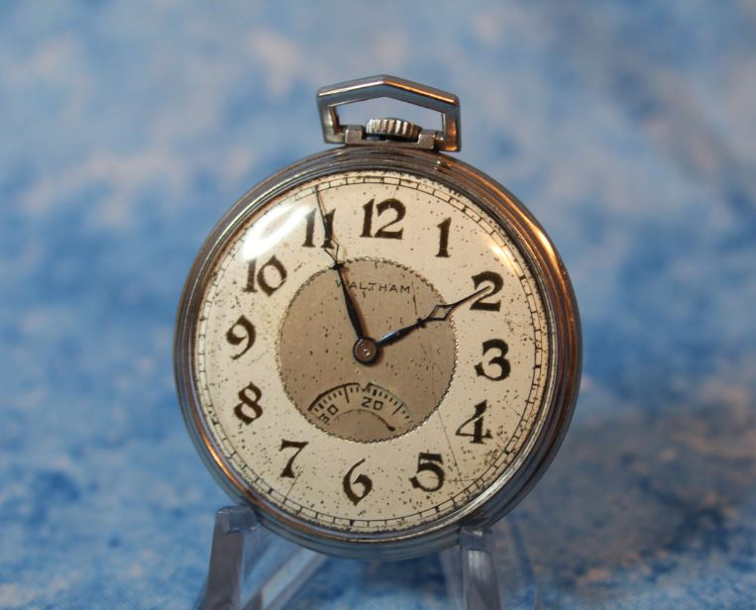
WNS-PW-6008 - Waltham - Digital Seconds - Full Front View | WNS-PW-6008 - Waltham - Digital Seconds - Left Front View
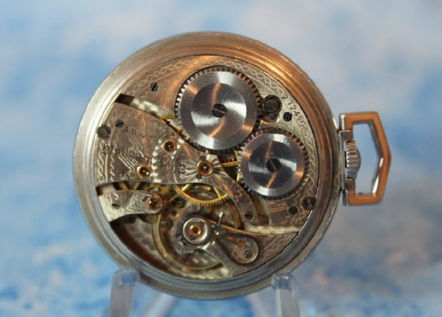 | 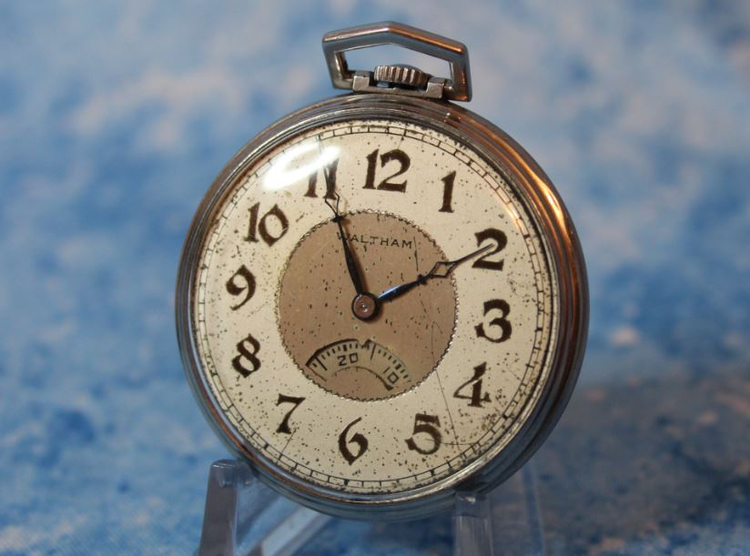
WNS-PW-6008 - Waltham - Digital Seconds - Movement View | WNS-PW-6008 - Waltham - Digital Seconds - Right Front View

Case: 12 size Open Face Case, 44.6 mm outside case diameter, 8 mm bow and stem length. Inside of Case Back marked Keystone, Metal and 424655.
Dial: An Art Deco influenced two toned dial (with aged patina) with an off white outer ring color and a silver inner ring color, Art Deco Arabic numerals, signed Waltham with an unusual arching seconds window between the 7 and 5 o’clock positions (in the 1930s this was referred to as a Digital Display).
Movement: Mechanical wind movement (stem wind). Signed Waltham USA., AWWCO, Adjusted, 17 Jewels, serial number 27,249,089 (circa 1930)
Comments: Interesting Art Deco era “Digital Seconds” display with nice dial patina in excellent mechanical condition (running fine.)

Item ID: WNS-PW-6008

