Side Quest: Governor Dick Observation Tower
Near Mt. Gretna in Lebanon County is the 1,105 acres of Governor Dick Park. It’s a perfect playground for those looking for adventure with numerous bouldering, hiking, and biking opportunities. Not to mention climb through the interior of a 66-foot tall tower.

Who was Governor Dick?
Governor Dick Park is not named after Dick Thornburgh, who served as the Pennsylvania Governor from 1979 to 1987. The name dates back at least 100 years before that to the 1880s when the mountain was described as “Governor Dix Hill.” It was named after an enslaved man, referred to as “Gov-nuh Dick,” who lived there in the mid-1800s. He was a woodchopper and charcoal burner who worked exclusively on the mountain felling and burning trees. He took hundreds of cords of wood from the spot on which the sixty-six-foot tall, circular observation tower now stands. After his death, this wooded area came to be called Governor Dix Hill and, more recently, Governor Dick.
Today, its official name is Clarence Schock Memorial Park at Governor Dick. Click here for more information about the park, including programs and hours.

Who was Clarence Schock?
Clarence started Schock Independent Oil Company with his father. Eventually, it grew to have 14 wholesale plants and a dozen gasoline service stations. He believed that after making provisions for his family, his estate should be used for the public’s general welfare. In 1941 he converted his business into a trust and provided that, except for a modest living for himself and his wife, its income should go to public schools in the districts served by his company.
Between the years 1934 and 1940, Mr. and Mrs. Clarence Schock purchased 1105 acres of Governor Dick Mountain to “preserve its landmarks and maintain it as a woodland playground and public park.”. As early as 1936, Clarence made the mountain available to the public.

Tower House
In addition to observation towers from which visitors on a clear day could view five counties (more on that below), Schock constructed the Tower House.
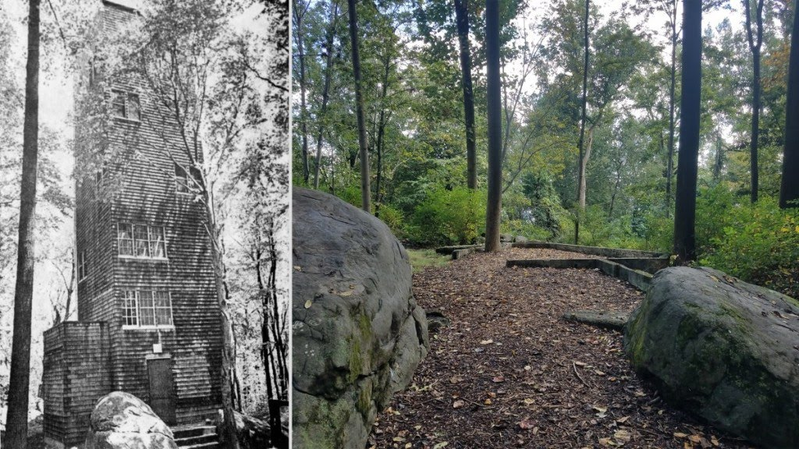The house and the site of its foundations. (The Lebanon Daily News / Joshua Groh)

Completed in 1938, the wooden house was to be Clarence and Evetta Schock’s summer residence. Unfortunately, the house was vandalized regularly, with fires being set and property being stolen. The Schocks seldom used the house as a result and stopped going there completely in 1949. It remained standing until 1974 when, for safety purposes, the Donegal School District—trustee of the Park at the time—tore the house down to its foundations.
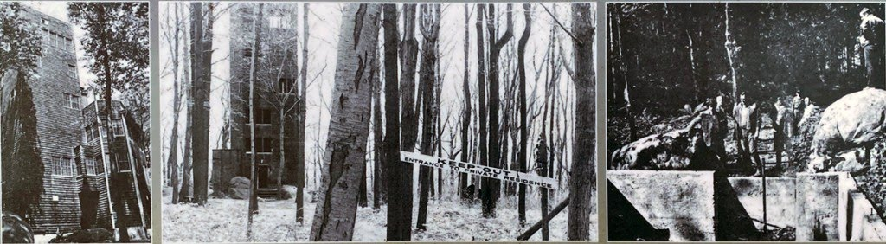The Tower House with keep out signs (center) and members of the Mt. Gretna Snowmobile Club overlooking the remains of the structure in 1974 (right).
The seven-story structure used a continuous climb ladder system to move among floors. Advancing age and illness later led the Schocks to install an elevator. The vertical structure was as much a tower as a house and resembled a coal break. It reflected Mr. Schock’s individual taste and fondness for the lands around Governor Dick. You can find the Tower House foundations here.
In 1998, Lebanon County & SICO Foundation were appointed trustees of the property. A board of six directors was appointed to oversee the property. In 2016 Lebanon County became the sole trustee.

Observation Tower
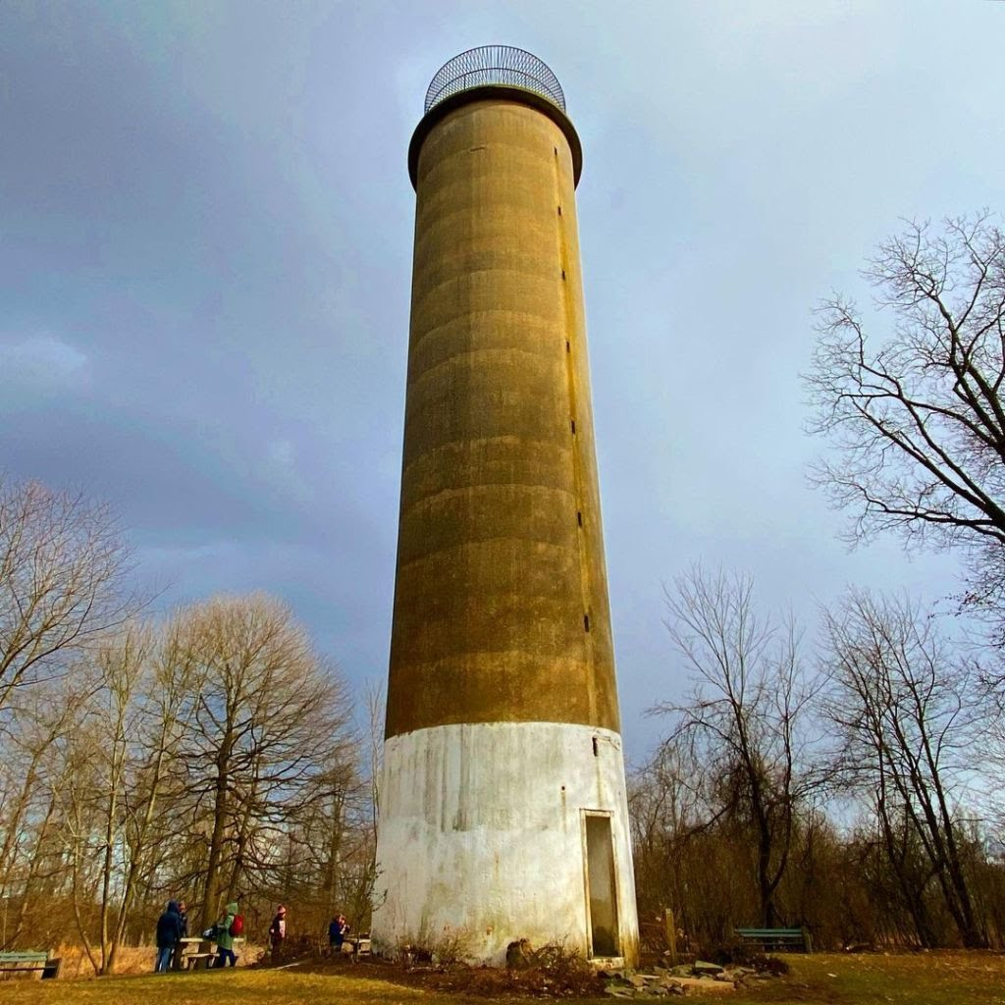
Observation Tower at Governor Dick Park

Near the Observation Tower is this informational kiosk. A full transcript can be found below.
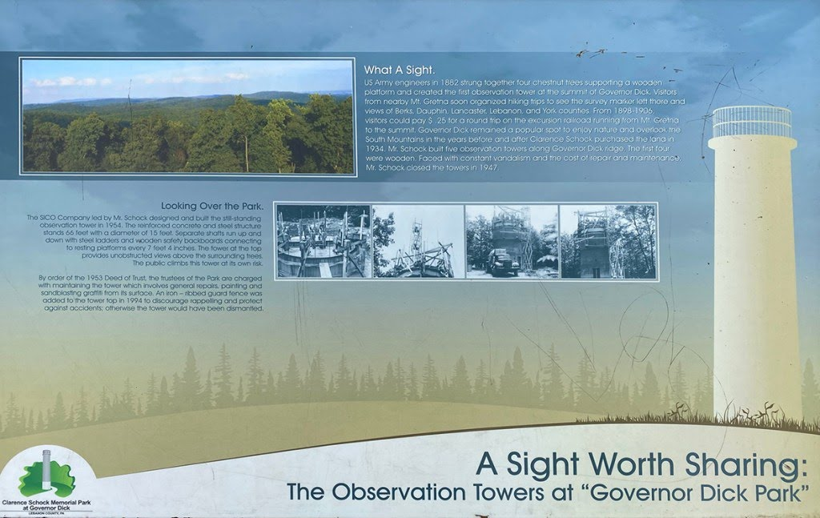Informational sign at Observation Tower at Governor Dick Park

What A Sight
US Army engineers in 1882 strung together four chestnut trees supporting a wooden platform and created the first observation tower at the summit of Governor Dick. Visitors from nearby Mt. Gretna soon organized hiking trips to see the survey marker left there and views of Berks, Dauphin, Lancaster, Lebanon, and York counties.
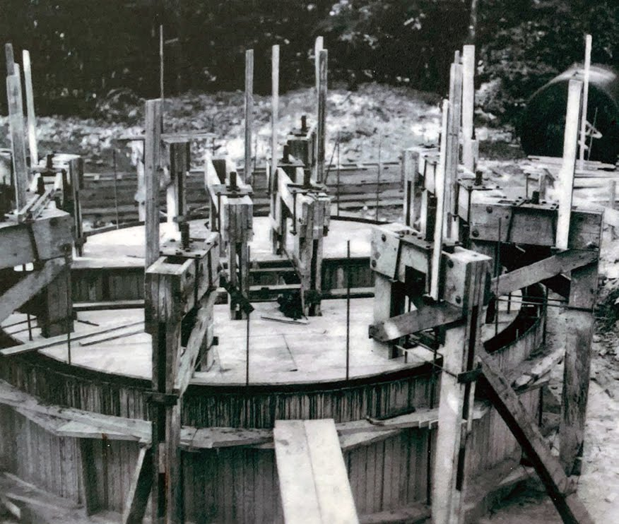
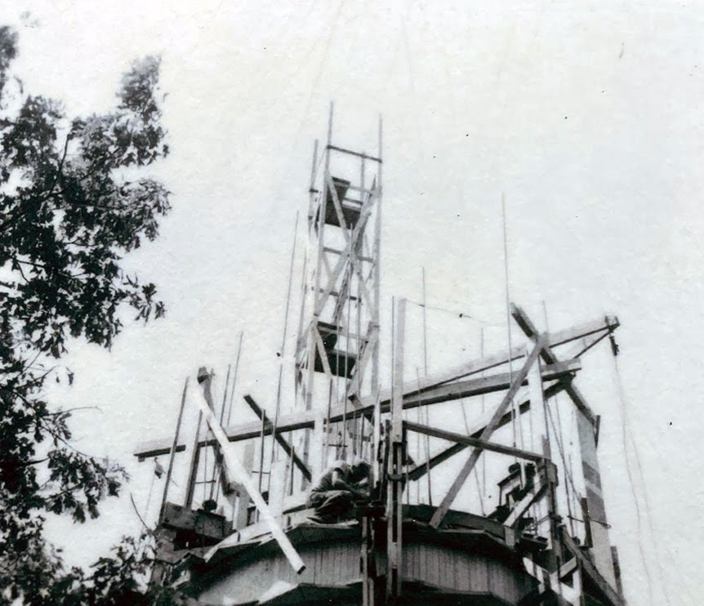
From 1898-1906, visitors could pay $ .25 for a round trip on the excursion railroad running from Mt. Gretna to the summit. Governor Dick remained a popular spot to enjoy nature and overlook the South Mountains in the years before and after Clarence Schock purchased the land in 1934. Mr. Schock built five observation towers along Governor Dick ridge. The first four were wooden. Faced with constant vandalism and the cost of repair and maintenance, Mr. Schock closed the towers in 1947.
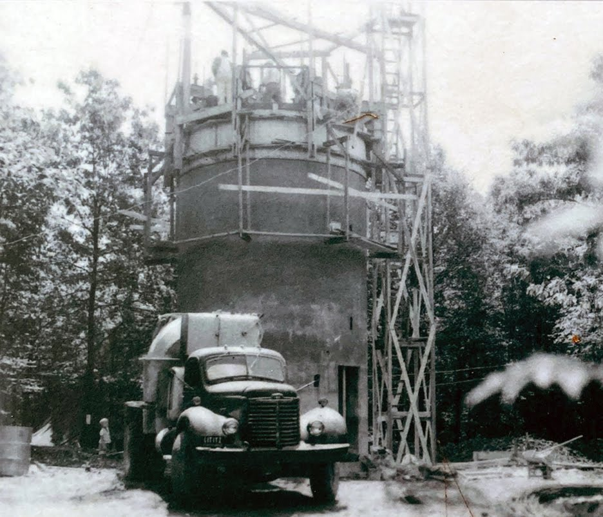
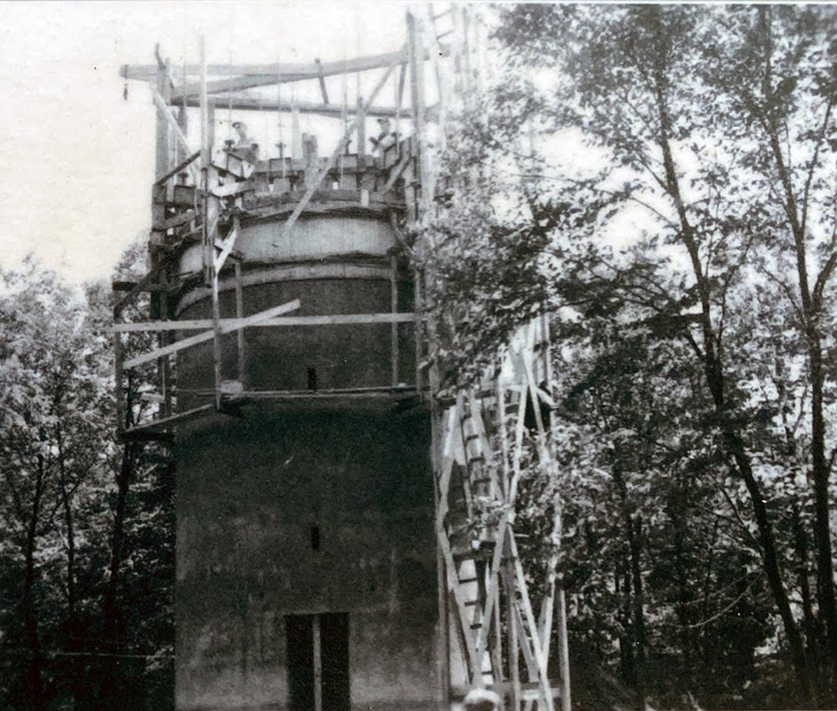

Looking Over the Park
The SICO Company, led by Mr. Schock, designed and built the still-standing observation tower in 1954. The reinforced concrete and steel structure stands 66 feet tall with a diameter of 15 feet. Separate shafts run up and down with steel ladders and wooden safety backboards connecting to resting platforms every 7 feet 4 inches.
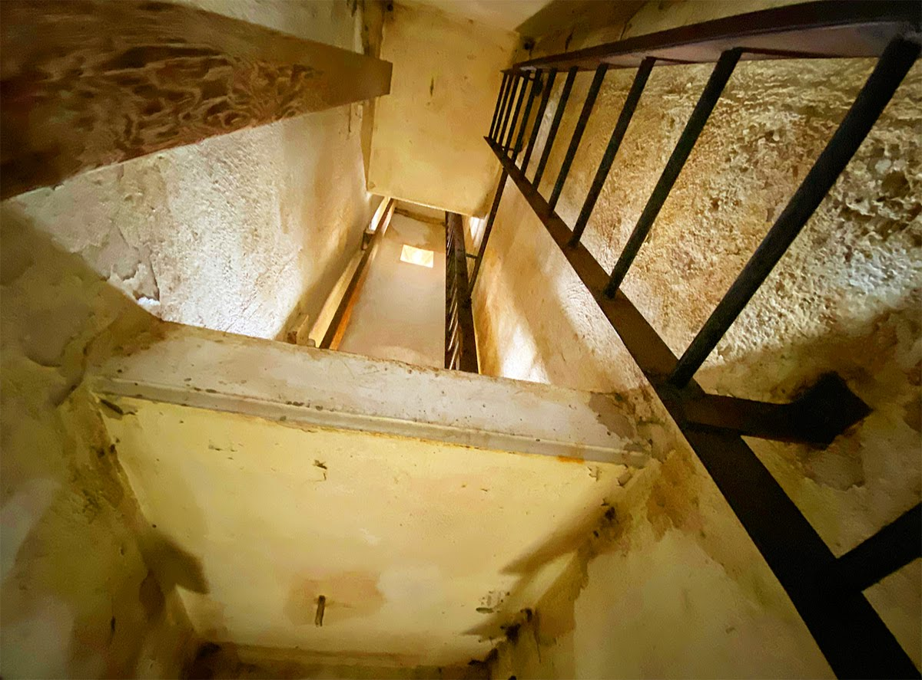
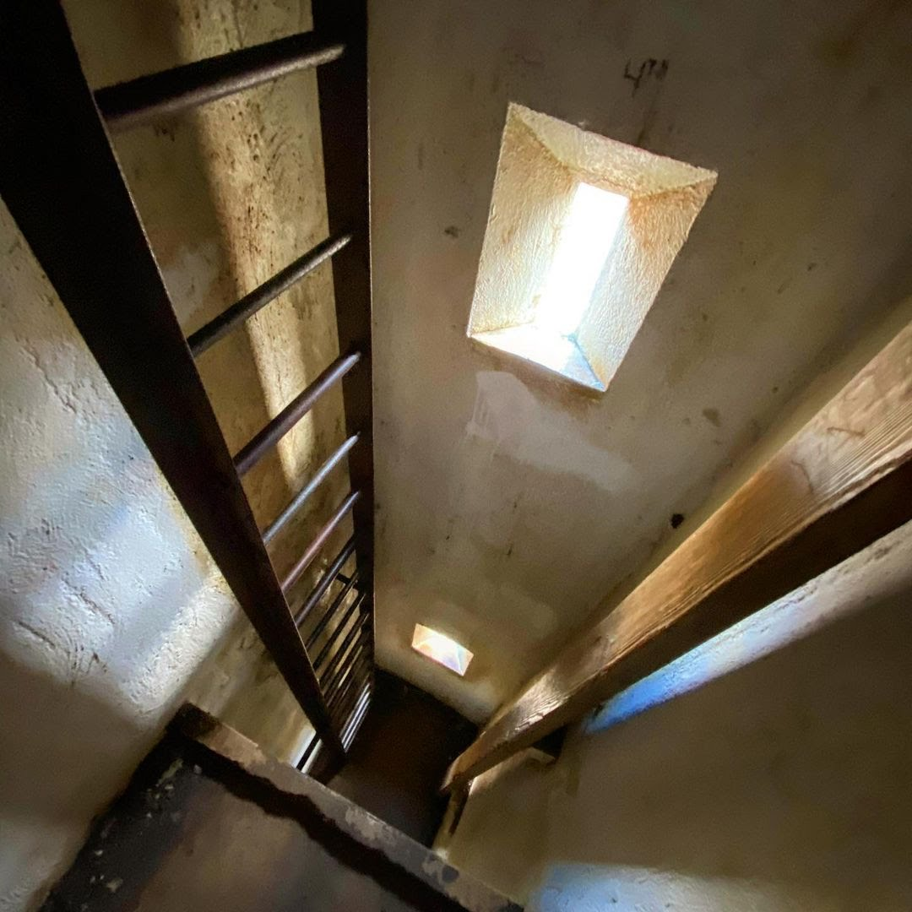
The tower at the top provides unobstructed views above the surrounding trees. Climb at your own risk.
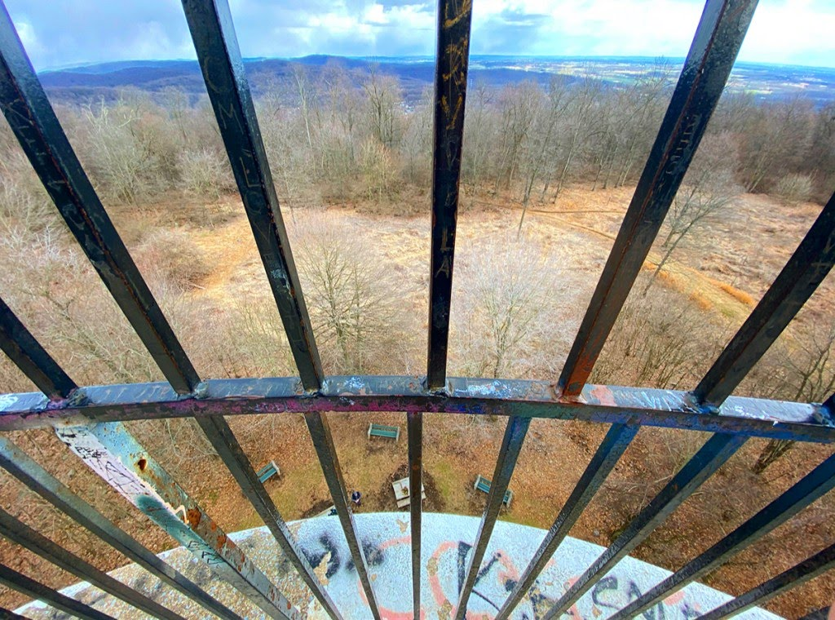
By order of the 1953 Deed of Trust, the Park’s trustees are charged with maintaining the tower, which involves general repairs, painting, and sandblasting graffiti from its surface. An iron-ribbed guard fence was added to the tower top in 1994 to discourage rappelling and protect against accidents; otherwise, the tower would have been dismantled.
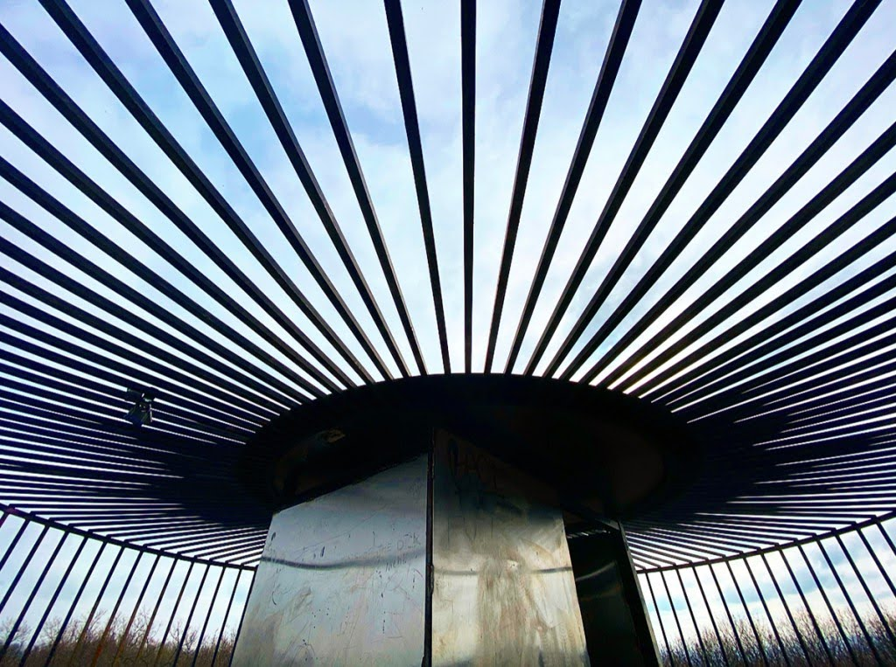
View from inside the tower’s cage.

Where to find it
The Governor Dick Observation Tower can be easily reached from the trailhead parking lot located on Pinch Road. From there, it’s a short half-mile hike. Here’s a pdf map of the park’s various trails. Although I prefer parking at the Environmental Center for better access to other sites of interest from inside the park. Here is the address: 3283 Pinch Rd, Lebanon, PA 17042.

Raiders of the Lost Ark
If you are looking to super-size your side quest, consider adding on this adventure. A short 500 yards away from the tower, the Ark of the Covenant lies hidden inside a massive rock shelter. Click here for information on locating it. Keep in mind you will have to bushwhack your way to it, but it’s a great find and awesome adventure. Just remember to keep your eyes shut when the lid is open.
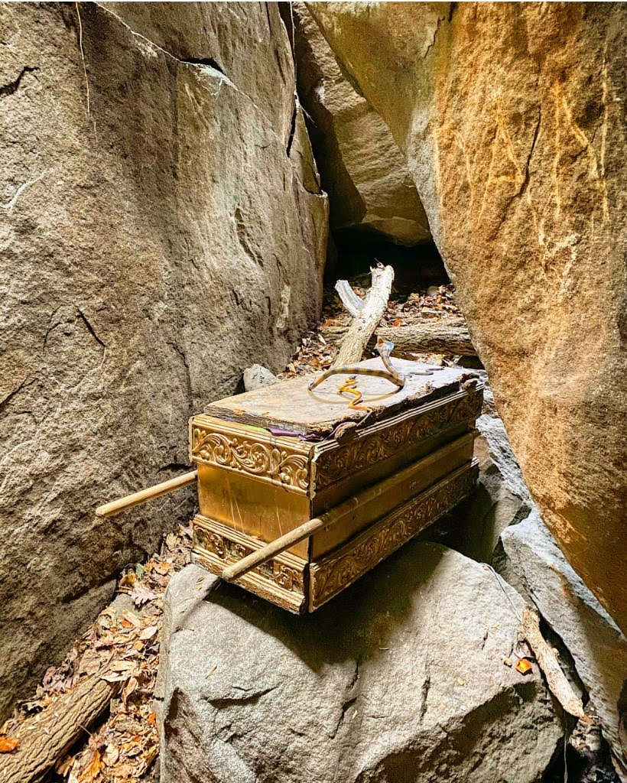
The current resting place for the Ark of the Covenant.

Collier’s Hut
This structure is a scaled-down example of a hut used by men called “colliers.” They made charcoal that was needed to produce iron at the Cornwall Iron Furnace. Colliers lived in huts near the charcoal pit to ensure the fire did not burn too hot or go out.
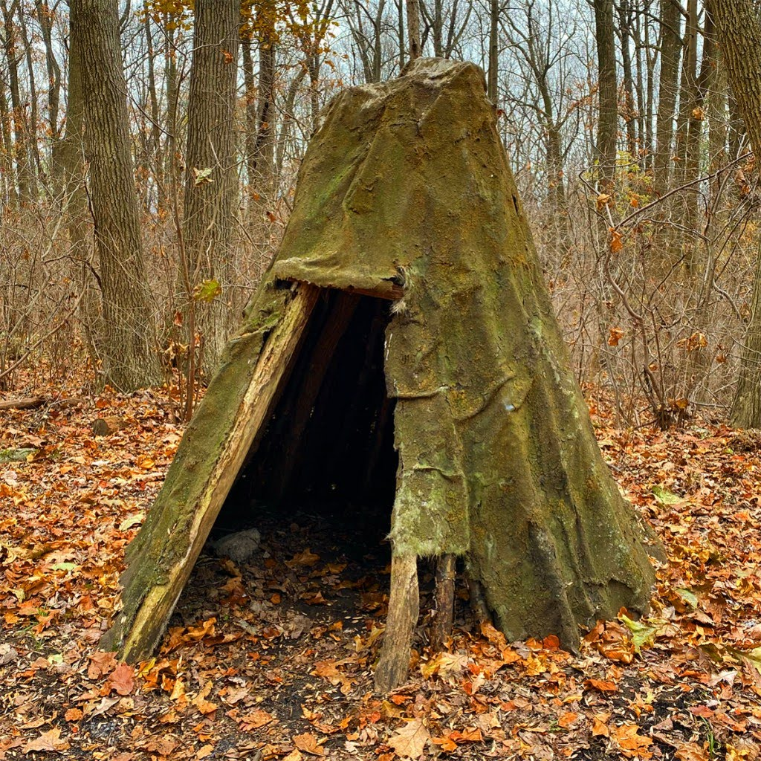
Collier Hunt

Colliers spent the winter months cutting hardwood species of trees and stacking the split, 3-4 foot logs in piles to season and dry. The burning or coaling season was from May through October to avoid dangerous winter weather conditions that made coaling difficult. The ideal trees were oak, hickory, chestnut, and other hardwoods. Pine and other softer woods were used occasionally but were not preferred.

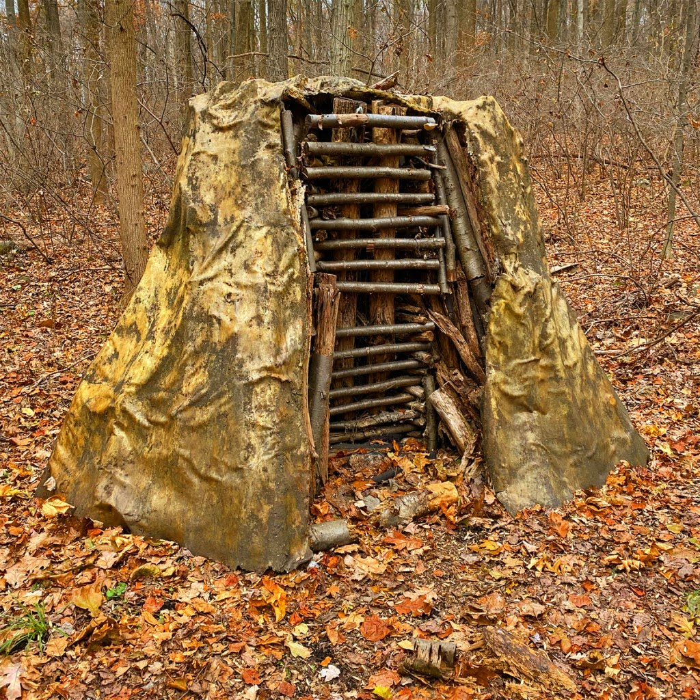
Charcoal Pit

It takes about one acre of forest to make enough charcoal for three tons of iron. The demand for charcoal was significant and eventually caused greater demand for a cheaper substitute, anthracite coal. You can find the Collier’s Hunt here a short distance from the Environmental Center parking lot.

Resources
- Clarence Schock Memorial Park at Governor Dick
- The sad story of the six-level “Tower House” that once stood atop Mt. Gretna’s Governor Dick
